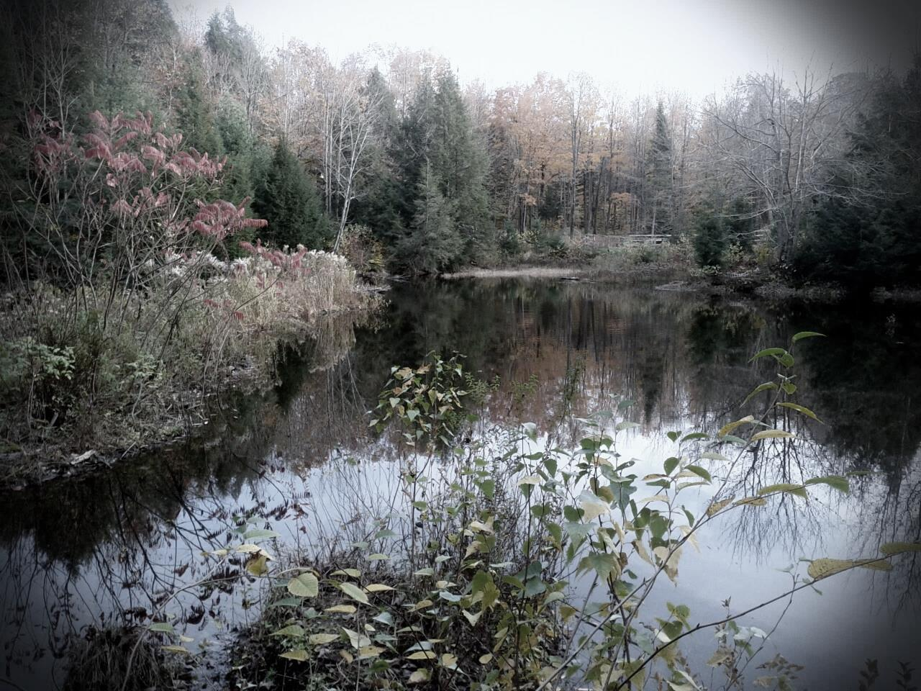
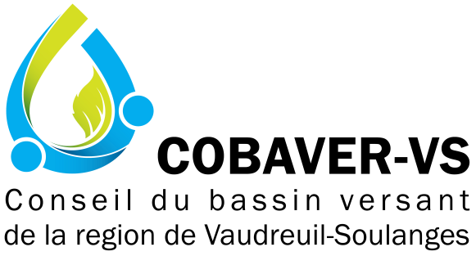

Membership Form
Becoming a member is… supporting the organization’s mission and mandates and showing how integrated watershed management is essential for regional development, for the common good.
- Invitation to activities and conferences, with preferential rates or even free admission
- Eligible to COBAVER-VS’ expertise
- Receive the COBAVER-VS’ newsletter and privileged information about the organization’s projects…
New membre
Renewal
Individual and non-profit organization 10$  Corporate member 50$  Municipality  - Less than 3,000 habitants 50$  - Between 3,001 and 12,000 habitants 100$  - More than 12,000 habitants 250$ | Enclosed amount :  Cash  Cheque  (payable to COBAVER-VS)
Activity sector for regular member (ex: agricultural, commercial, etc.)

MEMBER INFORMATION
Society/organization: | Postal code:
Name: | Phone:
Adress: | Email:

I am free to volonteer
I would like to make a donation of ____________ $
I would like to receive electronic newsletters
This is your receipt (copy for your file) – if required, an invoice can be sent.
Amount of 10$ 50$ 100$ 250$

For an annual membership 2018 to Conseil du bassin versant de la région Vaudreuil-Soulanges

Thank you for your precious collaboration

------------------------------------------------------------------------------------------------------------------
-102, rue St-Pierre, Rigaud (Qc), J0P 1P0, 450-451-0755, info@cobaver-vs.org, www.cobaver-vs.org-

